**EMPLOYEE TABLE**

**1. CREATE TABLE STATEMENT**

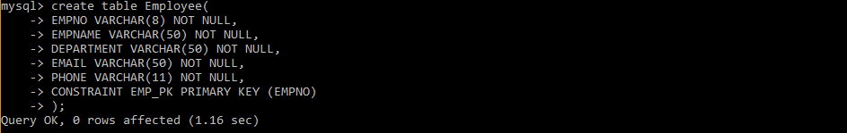

2. **INSERTING THE DATA**

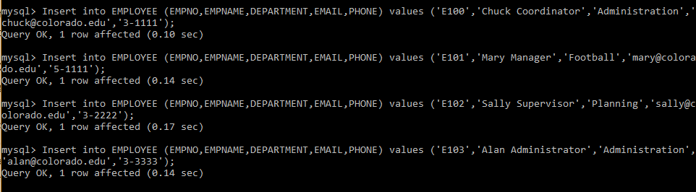

3. **TABLE DATA**

